Claire CHAILLOU-GILLETTE  GIS specialist  Paris | 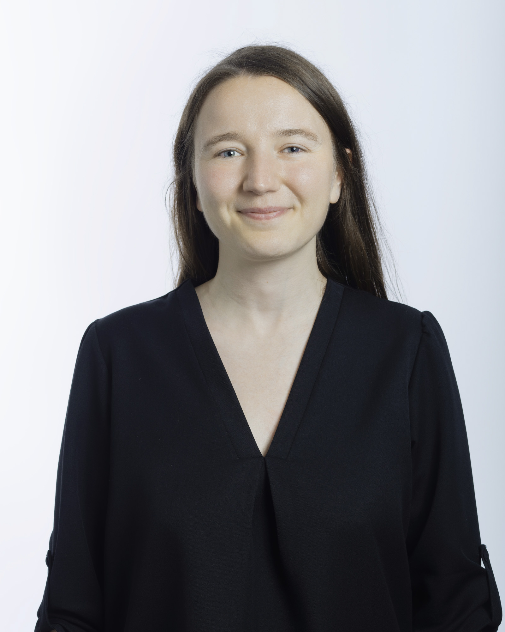 |  |  | Year of birth: 1992  Nationality: French  Language(s): English, German, Arabic (basic)

AREAS OF EXPERTISE
- Information Management and Geographic Information Systems (GIS)
- Data processing
- Spatial analysis
- Data visualization and cartography
WORK EXPERIENCE
Claire CHAILLOU-GILLETTE joined the GIS team of setec international in March 2022 after more than seven years of varied experience as a geographer specializing in cartography and geographic information systems. She has had the opportunity to work both in France and internationally in public and private organizations as well as a freelance cartographer.
Claire supports engineering and urban planning teams with spatial data collection and analysis. She designs the maps used for regional and local planning documents as well as the study reports and regulatory documents for major transport facilities and projects with the aim of supporting decision-making related to infrastructure and planning projects. She has also acted as technical lead and senior GIS specialist on projects including the set-up of comprehensive GIS systems, including web portals.
To this end, she uses her skills throughout the entire cartographic production chain:
- Support in defining requirements and managing information management projects (business analysis and product management, including as a certified Professional Scrum Product Owner™),
- Collection and compilation of data from multiple sources,
- Methodological support and implementation of spatial and statistical analysis methods, design of automated processing and handling of GIS software for production optimization,
- Production of static and web maps to materialize the results of the studies and to allow the elaboration of renderings adapted to the different stakeholders of the projects.
EDUCATIONAL BACKGROUND
l Master's degree in Geography - "Development Practices" specialty - Univ. Paris 1 Panthéon-Sorbonne (2015)
l Bachelor's degree in Geography - Univ. Paris 1 Panthéon-Sorbonne (2013)

MAIN REFERENCES
Information management and GIS - Major infrastructure projects
CERN - Environmental Information System of the Future Circular Collider (2022/ongoing)
GIS engineer, technical lead - Support for the definition of needs and coordination of the business analysis, coordination with the team in charge of software development, supervision of data collection activities, methodological support, geomatics services - Tools: ArcGIS Pro, ArcGIS Portal
Urban planning
Art and Culture Foundation - Masterplan and Conservation Plan of the Old City of Bukhara (2024/In progress)
Senior GIS specialist – Technical lead of the geospatial coordination, data processing, GIS analysis and map production - Tools: QGIS, Lizmap
JSO/DASC – Regional and local plans for Jazan Region (2023/In progress)
Senior GIS specialist – Technical lead of the GIS support team, quality control - Tools: ArcGIS Pro, ArcGIS Portal
Urban development
Agglomération de la Région De Compiègne et de la Basse Automne - DAE of the station eco-district (2021/In progress)
GIS engineer - Mapping of identified issues, measures and impacts - Tools: ArcGIS
Rail transport
SNCF Réseau - Climate change resilience analysis of the Mediterranean Arc lines (2022/In progress)
GIS engineer – Set up of production guidelines, methodological support, definition of needs and implementation of a web GIS tool - Tools: ArcGIS Pro, ArcGIS Portal
SNCF Réseau - Project to reopen the Colmar-Fribourg - Grand Est line (2021/In progress)
GIS engineer – Synthetic mapping of the line and associated issues, quality control of data collected as part of the study - Tools: Qqis
SNCF Réseau - Creation of new links between Western Brittany and Pays de la Loire (2020/ongoing)
GIS Engineer - Mapping of transit options - Tools: ArcGIS
Road transport
SNCF Réseau - A13A14 Free flow (2022/In progress)
GIS Engineer – Set up of production guidelines, data collection, implementation of interactive mapping - Tools: ArcGIS Pro, ArcGIS Portal
Previous references
Urban planning (Citadia Group) (2019/2022)
Intercommunal and communal Local Urban Plans, including: Laval Agglomeration (53), Pays du Saintois (54), Communities of Communes of the Joinville and Saint-Dizier Basin (52), Metz Eurometropolis (57), Courbevoie (91)
Cartographer and GIS specialist - Analysis, visualisation of data and cartography at all stages of the preparation of the zoning document: territorial diagnosis and land analysis, initial state of the environment, Planning and Sustainable Development Project and urban planning regulations, according to the standards in force (CNIG) - Tools: Qgis, Adobe Illustrator
Schémas de Cohérence Territoriale, including: Pays du Cambrésis (59), Pays Vitryat (51), Communauté d'Agglomération de Marne-et-Gondoire (77)
Cartographer and GIS specialist - Analysis, visualisation of data and cartography at all stages of the preparation of the planning document: territorial diagnosis and land analysis, initial state of the environment, Planning and Sustainable Development Project (now Strategic Planning Project) and Objectives and Guidelines Document, according to the standards in force (CNIG) - Tools: Qgis, Adobe Illustrator
Thematic studies, including the bicycle plan for the city of Saint-Prix (95) and an analysis of the pressures on the heritage of Greater Nancy (54)
Cartographer and GIS specialist - Analysis, visualisation of data and cartography for territorial diagnosis, prospective and for awareness and communication initiatives - Tools: Qgis, Adobe Illustrator
Support for methodological works (land analysis, Zéro Artificialisation Nette) and coordination of the geomatics team for the two agencies of the northern half of France
Various issues: analysis and valorisation of data (freenlance cartographer) (2017/2019)
Atlas of Contemporary Egypt (2018-2020, project led by the CEDEJ/Ministry of Foreign Affairs/CNRS)
Graphic and cartographic coordination, layout of the entire atlas - Tools: Qgis, Adobe Illustrator & InDesign
Atlas of Lebanon (2016 and 2019, project led by the NCSR-Lebanon and the Institut Français du Proche-Orient/Ministère des Affaires Etrangères/CNRS)
Graphic and cartographic coordination of two editions of the Atlas of Lebanon (2016 edition in French, 2019 in English), preparation of contributions on environmental issues - Tools: Qgis, Adobe Illustrator, Adobe InDesign
Study on the contribution of European youth organisations to the implementation of the 2030 Agenda and the Sustainable Development Goals (2018, project conducted for the European Youth Forum)
Coordination of the study, surveys, data collection and analysis, preparation of the final report
Support in information management and methodology for spatial data collection and processing on various projects
Design and delivery of training courses: introduction to editorial cartography, advanced training in visualization and valorization of spatial data

Protection and enhancement of natural areas (Conservatoire du Littoral) (2016/2017)
Overseas Delegation - GIS and Land Acquisitions Officer - Data collection and analysis, cartographic design, follow-up of land acquisition-related projects
Publications
Gillette, C., Amat, B., and Stefani, M., 2019, for the European Youth Forum, European Youth Organisations' and the 2030 Agenda, European Youth Forum, 79 p.
Gillette, C., Verdeil, E. and Faour, G., 2017, "Les défis du "Pays des Cèdres"", Carto, n°43, September-October 2017, pp. 12-23
Shaban, A., and Gillette, C., 2016 (in French) and 2019 (in English), "Changement(s) climatique(s) : des tendances difficiles à déterminer" in Verdeil, E., Faour, G. and Hamzé, M., Atlas du Liban : Les nouveaux défis, Beirut : CNRS-Liban/IFPO, pp. 64-65
Abdallah, C., Cartier, S., and Gillette, C., 2016 (in French) and 2019 (in English), "Une réponse institutionnelle incomplète" in Verdeil, E., Faour, G. and Hamzé, M., idem, pp. 72-73
Gillette, C., 2013, "SIG Atlas de Bamako: Construction et utilisation de la base de données", Service Cartographie de la DIC, Institut de Recherche pour le Développement, 65 p.

LANGUAGE SKILLS
l English: advanced
l German: intermediate
l Arabic: basic

